LAB 8 - Deployment View & Quality Attribute Analysis (ATAM)

1. UML Deployment Diagram

Deployment Diagram

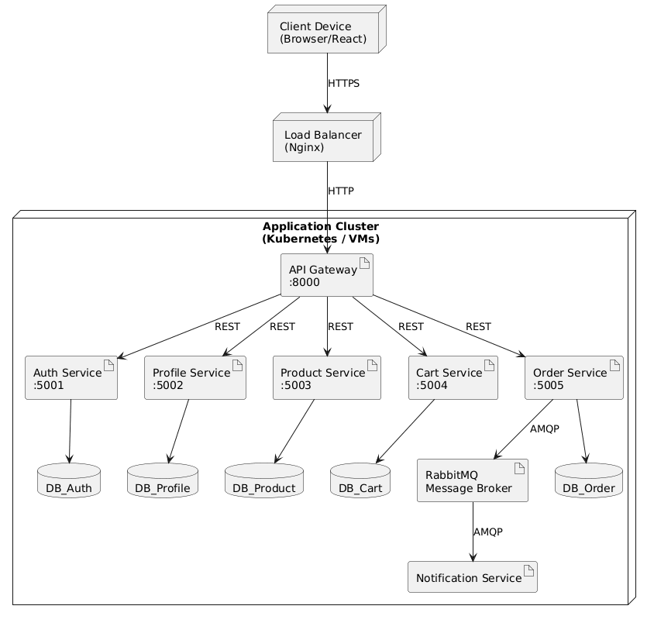

Communication Links
Source | Destination | Protocol
Client Device | Load Balancer | HTTPS
Load Balancer | API Gateway | HTTP
API Gateway | Product Service | REST
API Gateway | Cart Service | REST
API Gateway | Auth Service | REST
API Gateway | Profile Service | REST
API Gateway | Order Service | REST
Order Service | RabbitMQ | AMQP
RabbitMQ | Notification Service | AMQP

2. ATAM Analysis Table
Quality Attribute | Scenario | Monolithic (Layered) Approach | Microservices Approach
Scalability | SS1: During a 5-minute Black Friday promotion, the system must handle a 10x increase in users viewing products and adding items to carts. | The entire application must be scaled together, including UI, business logic, and database. This wastes resources because only a few functions need extra capacity. | Product Service and Cart Service can be scaled independently. Additional instances can be deployed only for heavily loaded services. This is more efficient and cost-effective.
Availability | AS1: Notification Service fails for 1 hour because of a deployment error. The system must continue accepting orders. | If notification functionality is integrated into the main application flow, order processing may fail or become slower, reducing system availability. | Order Service publishes events to RabbitMQ. Even if Notification Service is unavailable, orders are still processed normally. Messages remain in the queue and are han

3. Trade-off Statement
The Microservices Architecture provides better scalability and availability than the Monolithic Architecture. Services such as Product Service and Cart Service can be scaled independently to handle increased traffic, improving resource efficiency. Through the use of RabbitMQ and event-driven communication, failures in Notification Service do not affect Order Service, ensuring fault isolation and higher availability. However, Microservices introduce additional complexity, including service deployment, API Gateway management, message brokers, monitoring, and database management. In contrast, the Monolithic Architecture is simpler to develop and deploy but offers lower scalability and resilience.

